DEPARTMENT OF SOFTWARE ENGINEERING MOBILE APPLICATIONDEVELOPMENT (SE-487)

**LAB SESSION 13**

**Splash Screen & Navigation**

**Objective**

The objective of this lab session is to familiarize yourself with key concepts in Flutter mobile application development: Splash Screen, Navigator.push, and Navigator.pop. By the end of this lab, you will understand how to implement a splash screen for an initial loading experience and utilize Navigator.push to navigate between screens, along with using Navigator.pop to return to the previous screen.

**Introduction:**

In Flutter applications, a **splash screen** is the initial screen that appears when the app is launched. It serves as an introductory screen that typically displays the app logo, branding, or a loading indicator while the app initializes its resources or performs necessary tasks. The Navigator.push method is used to navigate from one screen to another within the app, pushing a new screen onto the navigation stack. Conversely, Navigator.pop is used to remove the current screen from the stack and return to the previous screen.A screen or activity in flutter is a class which can either be defined in the same file or added in a different dart file.

import 'package:flutter/material.dart'; 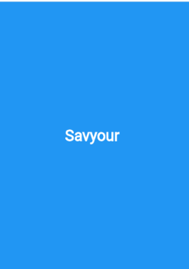

import 'dart:async';

void main() {

runApp(const MyApp());

}

class MyApp extends StatelessWidget {

const MyApp({super.key});

@override

Widget build(BuildContext context) {

return MaterialApp(

title:'flutter demo',

debugShowCheckedModeBanner: false,

theme:ThemeData(

primarySwatch:Colors.lightGreen,

),

home:const MyHomePage(),

);

}

}

class MyHomePage extends StatefulWidget {

const MyHomePage({Key?key}):super(key:key);

@override

State<MyHomePage> createState() => _MyHomePageState();

}

class _MyHomePageState extends State<MyHomePage>

{

@override

Widget build(BuildContext context) {

DEPARTMENT OF SOFTWARE ENGINEERING MOBILE APPLICATIONDEVELOPMENT (SE-487)

return SplashScreen();

}

}

class SplashScreen extends StatefulWidget {

State <SplashScreen> createState()=>_SplashScreenState();

}

class _SplashScreenState extends State<SplashScreen>{

void initState()

{

Timer(Duration(seconds:5),()

{

Navigator.pushReplacement(context,MaterialPageRoute(builder: (context)=>LoginPage(),)); }

);

super.initState();

}

Widget build(BuildContext context) {

return Scaffold(

body:Container(

color: Colors.blue,

child:Center(child:Text('Savyour',style:TextStyle(fontWeight:FontWeight.bold,color: Colors.white,fontSize: 34))

)

)

);

}

}

class LoginPage extends StatelessWidget

{

var emailText=TextEditingController();

var passText=TextEditingController();

@override

Widget build(BuildContext context) {

return Scaffold(

DEPARTMENT OF SOFTWARE ENGINEERING MOBILE APPLICATIONDEVELOPMENT (SE-487)

body: Center(

child: Container(

// color:Colors.lightBlue,

width :300,

child: Column(

mainAxisAlignment: MainAxisAlignment.center,

children: [

TextField(

controller: emailText,

keyboardType:TextInputType.phone,

//enabled: false,

decoration: InputDecoration(

focusedBorder: OutlineInputBorder(

borderRadius: BorderRadius.circular(21),

borderSide: BorderSide(color: Colors.cyan,width: 3)

),

enabledBorder: OutlineInputBorder(

borderRadius: BorderRadius.circular(21),

borderSide: BorderSide(color: Colors.green,width: 3)

),

disabledBorder: OutlineInputBorder(

borderRadius: BorderRadius.circular(21),

borderSide: BorderSide(color: Colors.yellow,width: 3)

), 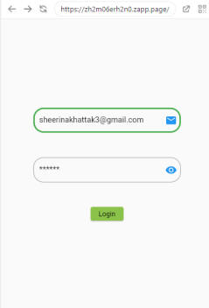

border: OutlineInputBorder(

borderRadius: BorderRadius.circular(21)

),

// suffixText: "user name",

hintText: 'enter email here...',

suffixIcon: IconButton(

icon:Icon(Icons.mail,color:Colors.blue),

onPressed: (){

},

),

// prefixIcon:Icon(Icons.phone,color: Colors.blue),

),),

Container(height:50),

TextField(

obscureText: true,

obscuringCharacter: '*',

controller: passText,

decoration: InputDecoration(

hintText: 'enter password here...',

border: OutlineInputBorder(

DEPARTMENT OF SOFTWARE ENGINEERING MOBILE APPLICATIONDEVELOPMENT (SE-487)

borderRadius: BorderRadius.circular(21)

),

suffixIcon: IconButton(

icon:Icon(Icons.remove_red_eye,color:Colors.blue),

onPressed: (){

},

),

),

),

Container(height:50),

ElevatedButton(

onPressed:(){

String uEmail=emailText.text.toString();

String uPass=passText.text.toString();

print("name:$uEmail password:$uPass");

}, child:Text('Login'))

],

)))

);

}

}

Passing the values from one activity to another requires the updation of class constructor

import 'package:flutter/material.dart';

import 'dart:async';

//import IntroPage.dart;

void main() {

runApp(const MyApp());

}

class MyApp extends StatelessWidget {

const MyApp({super.key});

@override

Widget build(BuildContext context) {

return MaterialApp(

title:'flutter demo',

debugShowCheckedModeBanner: false,

theme:ThemeData(

//primarySwatch:Colors.lightGreen,

),

home:const MyHomePage(),

);

}

}

DEPARTMENT OF SOFTWARE ENGINEERING MOBILE APPLICATIONDEVELOPMENT (SE-487)

class MyHomePage extends StatefulWidget {

const MyHomePage({Key?key}):super(key:key);

@override

State<MyHomePage> createState() => _MyHomePageState();

}

class _MyHomePageState extends State<MyHomePage>

{

@override

Widget build(BuildContext context) {

return SplashScreen();

}

}

class SplashScreen extends StatefulWidget {

State <SplashScreen> createState()=>_SplashScreenState();

}

class _SplashScreenState extends State<SplashScreen>{

void initState()

{

Timer(Duration(seconds:5),()

{

Navigator.pushReplacement(context,MaterialPageRoute(builder: (context)=>LoginPage(),)); } 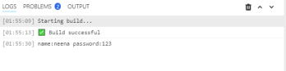

);

super.initState();

}

Widget build(BuildContext context) {

return Scaffold(

body:Container(

color: Colors.blue,

child:Center(child:Text('Savyour',style:TextStyle(fontWeight:FontWeight.bold,color: Colors.white,fontSize: 34))

)

)

);

}

DEPARTMENT OF SOFTWARE ENGINEERING MOBILE APPLICATIONDEVELOPMENT (SE-487)

}

class LoginPage extends StatelessWidget 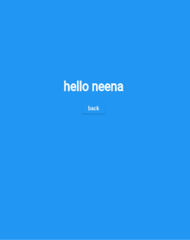

{

var emailText=TextEditingController();

var passText=TextEditingController();

@override

Widget build(BuildContext context) {

return Scaffold(

body: Center(

child: Container(

// color:Colors.lightBlue,

width :300,

child: Column(

mainAxisAlignment: MainAxisAlignment.center,

children: [

TextField(

controller: emailText,

keyboardType:TextInputType.phone,

//enabled: false,

decoration: InputDecoration(

focusedBorder: OutlineInputBorder(

borderRadius: BorderRadius.circular(21),

borderSide: BorderSide(color: Colors.cyan,width: 3)

),

enabledBorder: OutlineInputBorder(

borderRadius: BorderRadius.circular(21),

borderSide: BorderSide(color: Colors.green,width: 3)

),

disabledBorder: OutlineInputBorder(

borderRadius: BorderRadius.circular(21),

borderSide: BorderSide(color: Colors.yellow,width: 3)

),

border: OutlineInputBorder(

borderRadius: BorderRadius.circular(21)

),

// suffixText: "user name",

hintText: 'enter user name..',

suffixIcon: IconButton(

icon:Icon(Icons.mail,color:Colors.blue),

onPressed: (){

},

),

DEPARTMENT OF SOFTWARE ENGINEERING MOBILE APPLICATIONDEVELOPMENT (SE-487)

// prefixIcon:Icon(Icons.phone,color: Colors.blue),

),),

Container(height:50),

TextField(

obscureText: true,

obscuringCharacter: '*',

controller: passText,

decoration: InputDecoration(

hintText: 'enter password here...',

border: OutlineInputBorder(

borderRadius: BorderRadius.circular(21)

),

suffixIcon: IconButton(

icon:Icon(Icons.remove_red_eye,color:Colors.blue),

onPressed: (){

},

),

),

),

Container(height:50),

ElevatedButton(

onPressed:(){

String uEmail=emailText.text.toString();

String uPass=passText.text.toString();

print("name:$uEmail password:$uPass");

Navigator.push(context,

MaterialPageRoute(builder: (context)=>ProfilePage(uEmail),

)

);

}, child:Text('Login'))

],

)))

);

}

}

class ProfilePage extends StatelessWidget

{

DEPARTMENT OF SOFTWARE ENGINEERING MOBILE APPLICATIONDEVELOPMENT (SE-487)

var fromhome ;

ProfilePage(this.fromhome);

Widget build(BuildContext context) {

return Scaffold(

// appBar: AppBar(title:Text('Profile')),

backgroundColor: Colors.blue,

body:Center(child: Container(

height:200,

width:200,

child:Center(child:Column(

children: [

Center(child:Text("hello $fromhome",style:TextStyle(fontWeight:FontWeight.bold,fontSize: 32,color: Colors.white))),

SizedBox(height: 20,),

ElevatedButton(

child:Text('back'),

onPressed: (){

Navigator.pop(context);

},

)

],

)

)

)

)

);

}}

DEPARTMENT OF SOFTWARE ENGINEERING MOBILE APPLICATIONDEVELOPMENT (SE-487)

**Exercise**

**1. Basic Splash Screen and Navigation:**

Create a Flutter application with a splash screen that transitions to a main screen with navigation to a detail screen.

**Implement Splash Screen:**

Display a splash screen for 3 seconds.

Navigate automatically to the main screen after the splash screen duration.

**Main Screen (HomeScreen):**

Include a button labeled "Go to Detail Screen".

Implement navigation using Navigator.push to navigate to the detail screen (DetailScreen).

**Detail Screen (DetailScreen):**

Display a detailed content view.

Include a button labeled "Go back to Home Screen".

Implement navigation using Navigator.pop to return to the main screen (HomeScreen).

Code

//Musadiuqe Hussain SE-21031

//Muhammad Asim SE-21045

import 'package:flutter/material.dart';

void main() {

  runApp(MyApp());

}

class MyApp extends StatelessWidget {

  @override

  Widget build(BuildContext context) {

    return MaterialApp(

      debugShowCheckedModeBanner: false,

      title: 'Splash Navigation App',

      theme: ThemeData(

        primarySwatch: Colors.blue,

      ),

      home: SplashScreen(),

    );

  }

}

class SplashScreen extends StatefulWidget {

  @override

  _SplashScreenState createState() => _SplashScreenState();

}

class _SplashScreenState extends State<SplashScreen> {

  @override

  void initState() {

    super.initState();

    Future.delayed(Duration(seconds: 3), () {

      Navigator.pushReplacement(

        context,

        MaterialPageRoute(builder: (context) => HomeScreen()),

      );

    });

  }

  @override

  Widget build(BuildContext context) {

    return Scaffold(

      body: Center(

        child: Text(

          'Splash Screen',

          style: TextStyle(fontSize: 24, fontWeight: FontWeight.bold),

        ),

      ),

    );

  }

}

class HomeScreen extends StatelessWidget {

  @override

  Widget build(BuildContext context) {

    return Scaffold(

      appBar: AppBar(

        title: Text('Home Screen'),

      ),

      body: Center(

        child: ElevatedButton(

          onPressed: () {

            Navigator.push(

              context,

              MaterialPageRoute(builder: (context) => DetailScreen()),

            );

          },

          child: Text('Go to Detail Screen'),

        ),

      ),

    );

  }

}

class DetailScreen extends StatelessWidget {

  @override

  Widget build(BuildContext context) {

    return Scaffold(

      appBar: AppBar(

        title: Text('Detail Screen'),

      ),

      body: Center(

        child: ElevatedButton(

          onPressed: () {

            Navigator.pop(context);

          },

          child: Text('Go back to Home Screen'),

        ),

      ),

    );

  }

}

Output

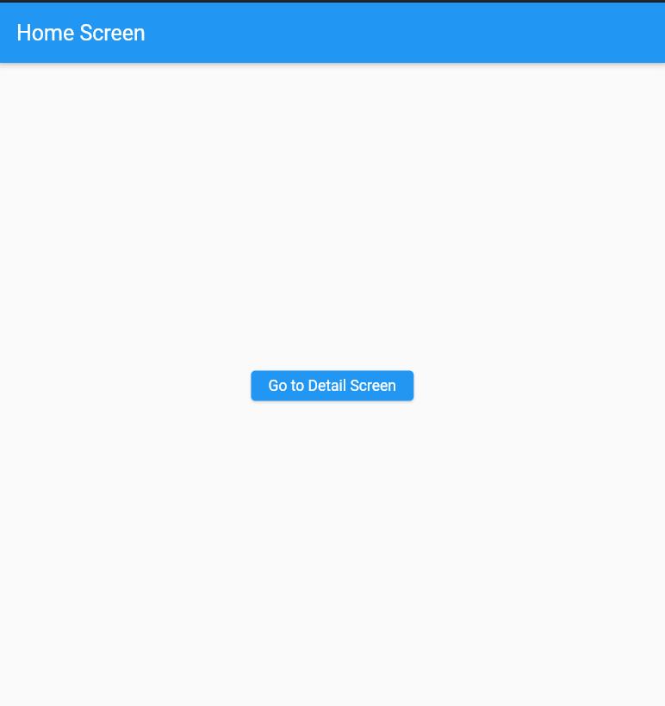

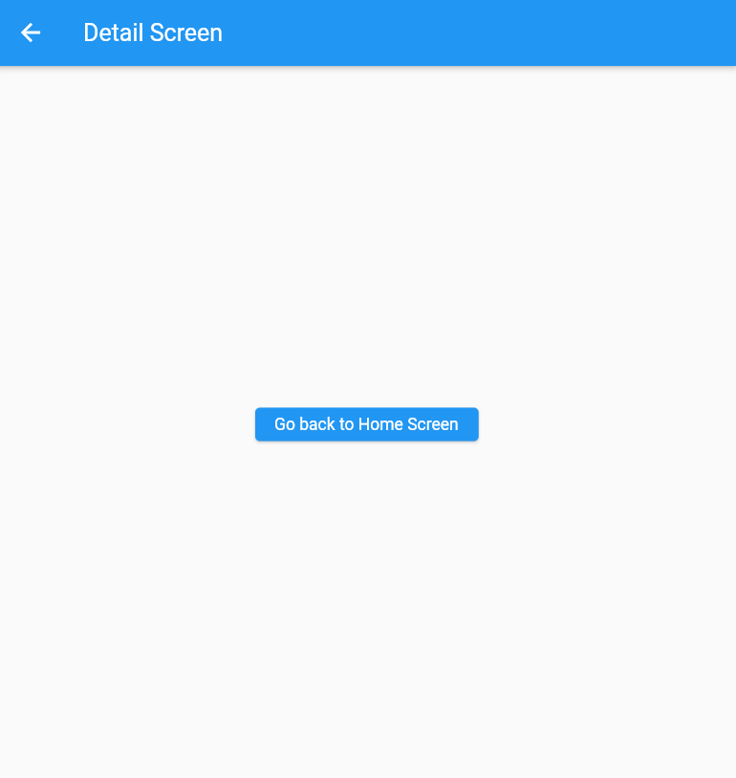

2. **Tabbed Navigation with Splash Screen**

Implement a Flutter application with a splash screen that leads to a tabbed interface for navigation between different screens.

**Implement Splash Screen:**

Display a splash screen with a loading indicator.

Navigate to a tabbed interface (TabbedNavigationScreen) after loading.

**Tabbed Navigation Screen (TabbedNavigationScreen):**

Include tabs for different categories (e.g., Home, Profile).

Implement tab navigation using DefaultTabController and TabBarView.

**Tab Screens:**

Create separate screens for each tab (e.g., HomeTab, ProfileTab).

Customize content and layout for each tab screen.

Code

import 'package:flutter/material.dart';

void main() {

  runApp(MyApp());

}

class MyApp extends StatelessWidget {

  @override

  Widget build(BuildContext context) {

    return MaterialApp(

      debugShowCheckedModeBanner: false,

      title: 'Tabbed Navigation App',

      theme: ThemeData(

        primarySwatch: Colors.blue,

      ),

      home: SplashScreen(),

    );

  }

}

class SplashScreen extends StatefulWidget {

  @override

  _SplashScreenState createState() => _SplashScreenState();

}

class _SplashScreenState extends State<SplashScreen> {

  @override

  void initState() {

    super.initState();

    Future.delayed(Duration(seconds: 3), () {

      Navigator.pushReplacement(

        context,

        MaterialPageRoute(builder: (context) => TabbedNavigationScreen()),

      );

    });

  }

  @override

  Widget build(BuildContext context) {

    return Scaffold(

      body: Center(

        child: Column(

          mainAxisAlignment: MainAxisAlignment.center,

          children: [

            CircularProgressIndicator(),

            SizedBox(height: 20),

            Text(

              'Loading...',

              style: TextStyle(fontSize: 24, fontWeight: FontWeight.bold),

            ),

          ],

        ),

      ),

    );

  }

}

class TabbedNavigationScreen extends StatelessWidget {

  @override

  Widget build(BuildContext context) {

    return DefaultTabController(

      length: 2, // Number of tabs

      child: Scaffold(

        appBar: AppBar(

          title: Text('Tabbed Navigation App'),

          bottom: TabBar(

            tabs: [

              Tab(icon: Icon(Icons.home), text: 'Home'),

              Tab(icon: Icon(Icons.person), text: 'Profile'),

            ],

          ),

        ),

        body: TabBarView(

          children: [

            HomeTab(),

            ProfileTab(),

          ],

        ),

      ),

    );

  }

}

class HomeTab extends StatelessWidget {

  @override

  Widget build(BuildContext context) {

    return Center(

      child: Text(

        'Home Tab',

        style: TextStyle(fontSize: 24),

      ),

    );

  }

}

class ProfileTab extends StatelessWidget {

  @override

  Widget build(BuildContext context) {

    return Center(

      child: Text(

        'Profile Tab',

        style: TextStyle(fontSize: 24),

      ),

    );

  }

}

Output

